Friends of the Earth Letter To Jan Tinetti
The Hon Jan Tinetti
Minister of Internal Affairs,
Parliament Buildings,
Wellington

July 26th, 2021

Dear Jan Tinetti,

We are writing to request you immediately stop the sale of some 600.000 books from the National Library. There are many disturbing aspects to this sale and these effectively destroy any credibility the library has as a safe place for literary material and as an institution that upholds the laws of copyright and protects the public property placed in its care.

1. There is evidence of falsification in the library's presentation of its case for sale. It is claimed that 90,000 items of Maori and Pasifika origin a year are produced and require storage space in the collections. Evidence gleaned from publisher's lists by journalists working for Spinoff media in an article published June 29th 2021 established that this figure is outlandishly exaggerated, and that items from all New Zealand publisher's lists published in the 2019 year in all subject areas came to an aggregated total of just 2662 new books.

2. No cultural institution can run properly on the basis of what we describe “either-or" decision-making. In this case the situation has been presented as: "either we cull 600,000 non-New-Zealand- published books or we can't acquire the Maori and Pasifika material that needs to be lodged with us." This is an oppositional decision that is completely unnecessary.
It presents a non choice and imposes it as reality on a generally well-meaning public who really do want to see cultural equity practiced by cultural institutions. The fact that data is mis-quoted in justifying this oppositional decision makes it all the worse. We want to see cultural equity too, and in our 46-year history of researching and campaigning on environmental issues have lent our help to Maori in issues in which their interests were being threatened by environmentally and economically destructive development schemes. We know that equity is not achieved by poorly prepared "either-or" binary decisions that, so often in public life, are used to justify bad ideas and worse projects.

"Either-or" is not good enough. We want a "both" decision-making system that honours the literary materials of Maori and Pasifika peoples and the literary materials, not only of New Zealanders who whakapapa to Britain and Europe, but New Zealanders who whakapapa to all the many cultures that now live here. Anything less is a travesty. "Both" decisions are inclusive, and inclusiveness in the matter of material held by a national library is axiomatic. Without it this library cannot claim to be to be national.

3. Perhaps the most disturbing factor in the cull is that the library has entered negotiations and is about to do business with an organization based in the USA, the US Internet Archive. This organization is in breach of international copyright law and is, right now, subject to a major lawsuit in the USA being brought against it by American publishers and authors. By entering into agreements that donate our property to an organization that is already being described as practicing the offence of literary "piracy", the library becomes an accessory to the fact of that offence. Given this, you, as minister need to investigate the legal and professional competencies of those in the library responsible for these decisions and reach a judgement as to whether they need re-training or disciplining. You also need to examine (if the American lawsuit proves the Internet Archive is culpable) the degree to which that decision will affect the reputation of New Zealand governments in running a state in which there is any respect for intellectual property and copyright law.

This has ramifications far beyond the fate of books in libraries and will redound negatively on our reputation in international trade and commerce forums.
4. We understand that the normal method of digitising books involves their physical destruction. Their covers and bindings are broken. They then have only an electronic presence. Their availability to readers is therefore limited in time. Studies published by Jeff Rothenberg in the Scientific American in 1995 (Volume 272 No 1) summed up the longevity of data as being 500 years or more for paper-based information and just five years on average for digital data. Since that discussion was published the precariousness of digital storage has greatly increased with the world-wide proliferation of criminal hacking and cyber warfare. The rapid turnover into obsolescence of IT storage and retrieval systems virtually guarantees that retrieval of digitally stored material by future generations is unlikely to be a practical reality. Here again an "either-or" decision is disastrous. By all means digitize material where it is advantageous to do so, but do not commit the folly of destroying the original documents.

5. There is an assumption made, we presume by senior library staff, that books not published here and not containing New Zealand content are, as it were, second-class literary citizens of little use to researchers and readers working here. Yet our economic scientific and cultural infrastructure depends, minute by minute, on information that is generated in countries other than our own. We have day by day experience of this as an environmental organization with 47 years experience of working here on a wide variety of issues. Two current examples. We are researching food irradiation. Almost all relevant data concerning this subject is generated outside New Zealand. We hold our own archive on this subject, but it is only a small part of what we need as the politics and regulations concerning food irradiation develop and evolve. New Zealand is linked by agreement with Australia in developing policy on this technology. Material held in the archives of both countries is vital to us. We are also researching genetic engineering and the scientific history and assumptions of that technology. A key text in the debate is Lamarck's Signature. How Retrogenes are Changing Darwin's Natural Selection Paradigm. Author. Dr Edward Steele. Publisher. Allen and Unwin. Sydney, 1998. Another key text in the development of science is The Structure of Scientific Revolutions. Author. Thomas Kuhn. Pub;isher. University of Chicago Press. Chicago 2012. This book was first published in the later 1960s. We are told by National Librarian Rachel Esson that much of the cull concerns books published in those years. Would you, as Minister make an enquiry as to whether Kuhn's book is in the National Library, and if so, whether it is due to be culled?

There are plenty equivalent examples in the arts. For instance, A Poet's Glossary. Author. Gerald Hirsch. Publisher. Houghton, Miflin, Harcourt. New York, 2014. There are now many active writing classes in this country. The Hirsch Glossary would be a must in any course on poetry. Books on the philosophy of music are thin on the ground, but important to students and writers of music history. One such is the compendious A History of Music Aesthetics. Author, Enrico Fubini. Publisher of English Edition, The Macmillan Press Limited, London, 1991.

It is not safe to assume that such texts will automatically be in the care of the tertiary education library systems. In recent years, universities, driven by the obscurantism of neo-liberal economics, have been mutilating their libraries. I instance the case of the dismantling of three specialist libraries at the University of Auckland in 2018: the Elam Library, the School of Music Library and the Architecture and Town Planning Library.
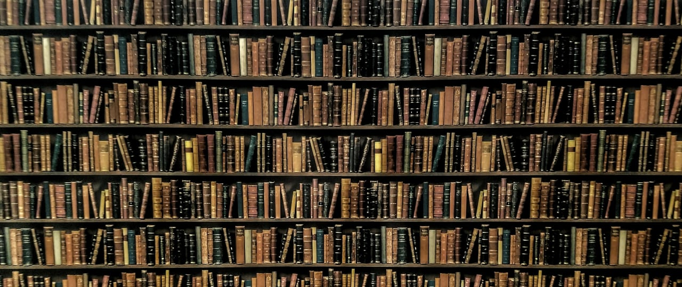
6. What is the capital value of 600,000 books that, in the main, will be hard covered, some with dust jackets, well designed from reputable publishers, and involving subjects from engineering to philosophy? We have taken the liberty of making a guess. A book of this kind, retailing in the second-hand bookshops now in this country could sell for $20-$40 NZ. If the average is the lower figure the books are worth $12 million NZ; if the median figure is taken
they are worth $18 million NZ. That is a lot of public money to "donate" to an internet business in the United States. I say "donate" because no hint has been given of any
payment being made to the National Library for our books. And I have sighted one explicit statement in recent media releases that says, yes, they will be donated.

7. The alternative to an "either-or" binary decision about these books and the library's storage strategy is not even mentioned in what I have so far seen of the library's policy.
Indeed, there seems to be no policy. Why has the "both" decision not been explored - of providing room to retain these books and to collect all Maori and Pasifika material as well?
The cost of adding storage space to the National Library, particularly as we now know that in total they would only have to deal with 2-3000 new acquisitions a year from regional and New Zealand sources, not the tens of thousands mentioned in that alarming 90,000 figure - that cost would be very moderate. Your government seems at the moment to be upbeat about the state of its finances. Perhaps this is the time to show a bit of largesse in the proper support of our cultural institutions.

Yours sincerely,

Dr Denys Trussell
For Friends of the Earth NZ
Spokesperson on Transport, Biotechnology and Wilderness issues.
Email office: foenz@ kcbbs.gen. nz
Email home:denys.trussell@gmail.com

For further reading and debate on the issue:
https://www.kiwiblog.co.nz/2020/01/the_600000_book_cull.html
https://www.newsroom.co.nz/ideasroom/2020/06/10/1224986/lest-we-forget-the-power-of-knowledge
https://bookguardiansaotearoa.com/2020/12/11/377/
https://www.theguardian.com/world/2020/sep/11/i-literally-weep-anguish-as-new-zealands-national-library-culls-600000-books
https://www.pundit.co.nz/content/fahrenheit-451

